

VOLUNTARY NON-REMUNERATED BLOOD DONATION

DETAIL DESIGN DOCUMENT

Screen Design

**Project Code: VNBD**

**Document Code: VNBD_ Screen Design_ v1.0_EN**

**<FPT University, 07/10/2013>**

Record of change

*A - Added M - Modified D – Deleted

|  |  |  |  |  |
| --- | --- | --- | --- | --- |
| Effective Date | Changed Items | A* M, D | Change Description | New Version |
| 07/10/2013 | Screen design | A | Create new | v0.1 |
| 11/10/2013 | Screen design | M | Update missing picture and label component | v0.9 |
| 20/10/2013 | Screen design | M | Update missing picture and label | v0.9.9 |
| 23/10/2013 | Screen design | M | Update version | v1.0 |
|  |  |  |  |  |
|  |  |  |  |  |
|  |  |  |  |  |
|  |  |  |  |  |
|  |  |  |  |  |
|  |  |  |  |  |
|  |  |  |  |  |
|  |  |  |  |  |

SIGNATURE PAGE

**RIGINATOR:** Pham Hung Cuong 07/10/2013

Developer

**REVIEWERS:** Pham Hung Cuong 07/10/2013

Developer

Ngo Tran Linh 13/10/2013

PM

**APPROVAL:** Bui Dinh Chien 23/10/2013

Supervisor

1 Introduction 5

1.1 Purpose 5

1.2 Definitions, Acronyms and Abbreviations 5

1.3 References 5

1.4 Overview 6

2 screen Flow 7

2.1 Homepage screen 8

2.2 View full post 10

2.3 News screen 12

2.4 Q&A 14

2.5 Contact screen 15

2.6 Blood’s storehouse 16

2.7 Register 18

2.8 Choose type of register (donate or receive) 19

2.9 Register to donate blood 20

2.10 Register to receive blood 21

2.11 Login screen 22

2.12 Forgot password screen 23

2.13 Term of service Screen 24

2.14 Edit profile screen 25

2.15 Gallery 28

2.16 View full picture 30

2.17 Videos 31

2.18 History of blood donate/receive registration (for admin) 32

2.19 View full History of blood donate/receive registration (for admin) 34

3 Other considerations 36

# Introduction

## Purpose

**1.1.1** **Purpose**

To ensure consistency and simplicity in detailed design across all displays within a product interface, as well as across other products used by the same users.

**1.1.2** **What are contain in the doc**

Definitions, acronyms, abbreviations, references and overview of VNBD system

**1.1.3** **Readers of this document**

VNBD’s developer team

## Definitions, Acronyms and Abbreviations

|  |  |  |
| --- | --- | --- |
| Abbreviations | Description | Comment |
| DOB | Date of birth |  |
| TOS | Terms of service |  |
| Q&A | Question and answer |  |
| DDL | Dropdown list |  |

## References

|  |  |
| --- | --- |
| Document Number | Title |
|  |  |

## Overview

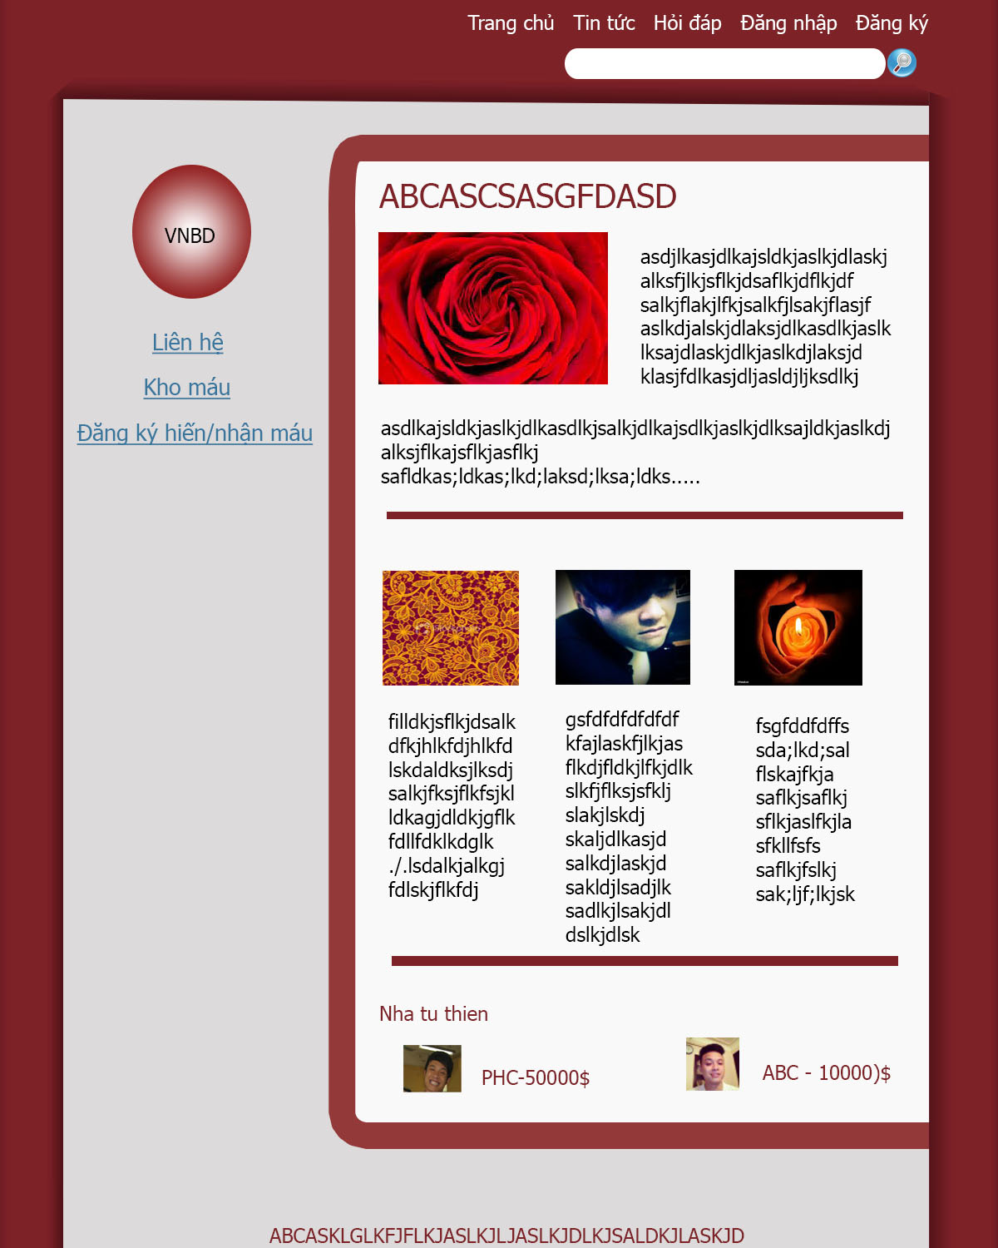

# screen Flow

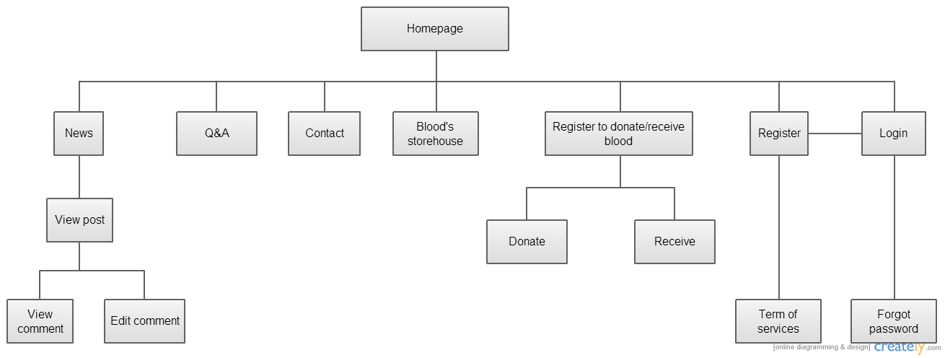

|  |  |  |
| --- | --- | --- |
| No | Screen Name | Description |
| 1 | Homepage | Homepage |
| 2 | View full post | View full post |
| 3 | News | View posts |
| 4 | Q&A | Display Question and Answer about VNBD group |
| 5 | Contact | Display how to contact with VNBD group |
| 6 | Blood’s storehouse | Display information about all user’s blood |
| 7 | Register | Register to be a member of page |
| 8 | Register to donate/receive blood | Choose what user want to register to (donate or receive blood) |
| 9 | Donate | Register to donate blood |
| 10 | Receive | Register to receive blood |
| 11 | Login | Login as a member |
| 12 | Forgot password | Contact to admin to reset password |
| 13 | Term of service | View term of services |
| 14 | Edit profile user | View and edit profile |

## Homepage screen



|  |  |  |  |  |  |
| --- | --- | --- | --- | --- | --- |
| No | Component Name | Required | Format | Reference | Note |
| 1 | Homepage | Click | Button | Homepage screen | Refresh homepage |
| 2 | News | Click | Button | News screen | Link to news screen |
| 3 | Q&A | Click | Button | Q&A screen | Link to Q&A screen |
| 4 | Contact | Click | Button | Contact screen | Link to Contact screen |
| 5 | Blood’s storehouse | Click | Button | Blood’s storehouse screen | Link to Blood’s storehouse screen |
| 6 | Register | Click | Button | Register screen | Link to register screen |
| 7 | Register to donate/receive blood | Click | Button | Register to donate/receive blood screen | Link to Register to donate/receive blood screen |
| 8 | Login | Click | Button | Login screen | Link to login screen |
| 9 | VNBD label |  | Text |  | Display VNBD label |
| 10 | Search textbox | Text | Text |  | Input search keyword |
| 11 | Search button | Click | Button |  | Search information |
| 12 | Highlight post |  | Text | Full post | Display highlight posts |
| 13 | Philanthropist label |  | Text |  | Display Philanthropist label |
| 14 | Philanthropist Picture |  | Image |  | Display Philanthropist Picture |
| 15 | Philanthropist’s donate number |  | Text |  | Display Philanthropist’s donate number |
| 16 | Slogan label |  | Text |  | Display Slogan label |

## View full post

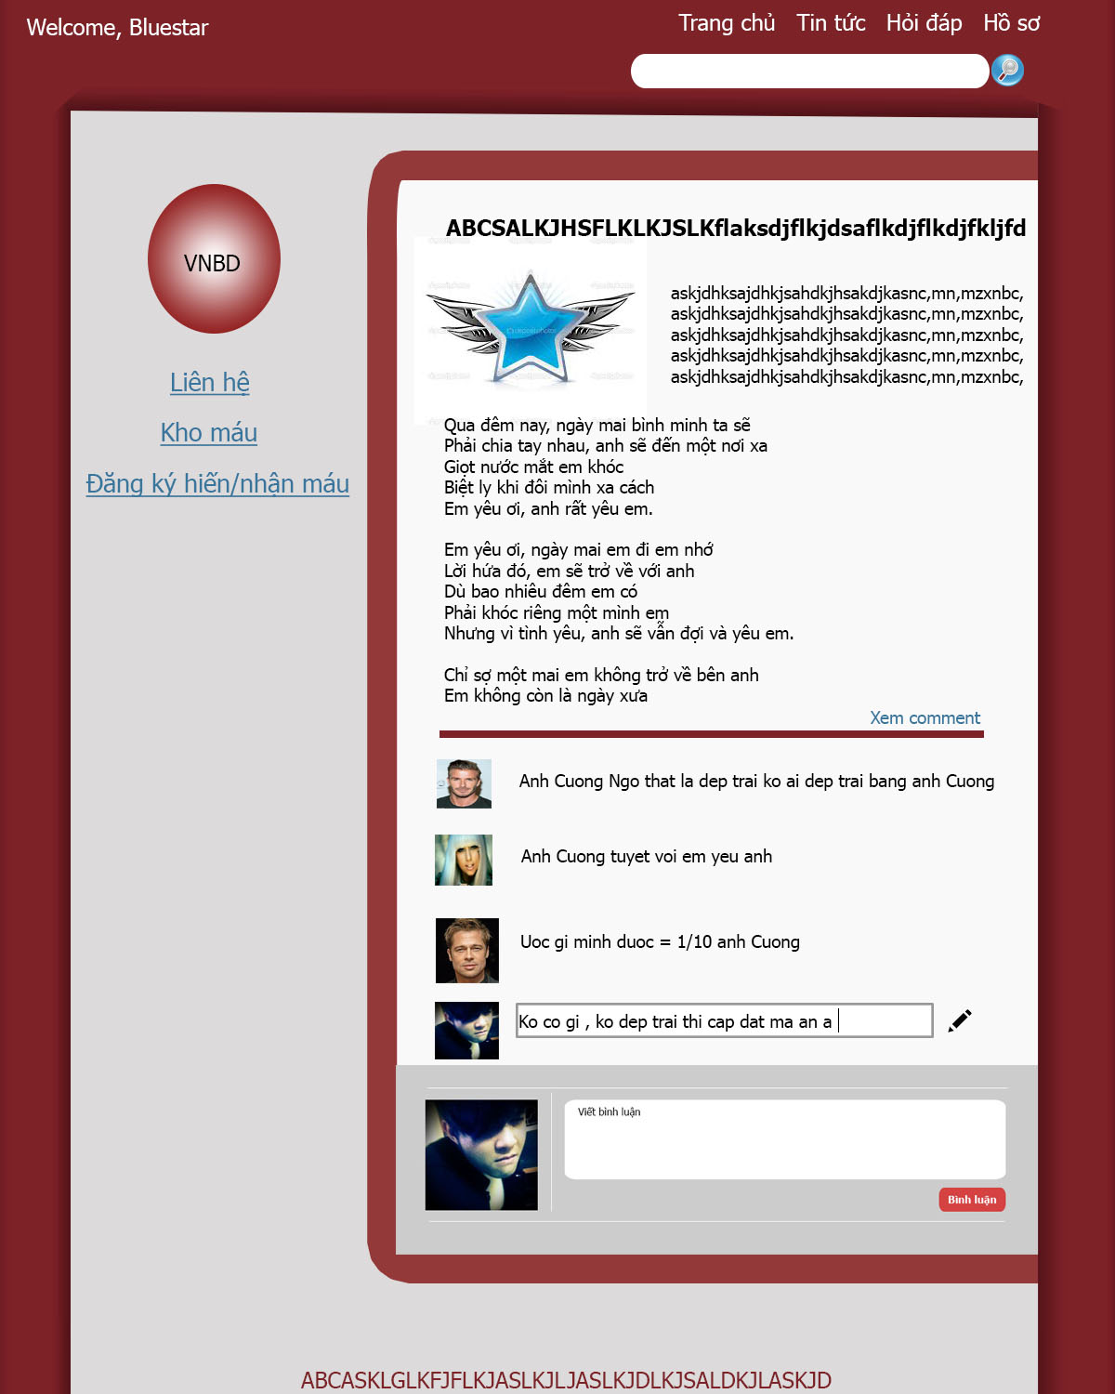

|  |  |  |  |  |  |
| --- | --- | --- | --- | --- | --- |
| No | Component Name | Required | Format | Reference | Note |
| 1 | Homepage | Click | Button | Homepage screen | Refresh homepage |
| 2 | News | Click | Button | News screen | Link to news screen |
| 3 | Q&A | Click | Button | Q&A screen | Link to Q&A screen |
| 4 | Contact | Click | Button | Contact screen | Link to Contact screen |
| 5 | Blood’s storehouse | Click | Button | Blood’s storehouse screen | Link to Blood’s storehouse screen |
| 6 | Register to donate/receive blood | Click | Button | Register to donate/receive blood screen | Link to Register to donate/receive blood screen |
| 7 | VNBD label |  | Text |  | Display VNBD label |
| 8 | Search textbox | Text | Text |  | Input search keyword |
| 9 | Search button | Click | Button |  | Search information |
| 10 | Slogan label |  | Text |  | Display Slogan label |
| 11 | Post’s name |  | Text |  | Display post’s name |
| 12 | Post’s pictures |  | Image |  | Display post’s picture |
| 13 | Post’s content |  | Text |  | Display post’s content |
| 14 | Welcome label |  | Text |  | Display: “welcome user “ |
| 15 | Profile | Click | Hyper link | Edit profile user screen | Link to edit profile screen |
| 16 | View Comment | Click | Button |  | Display all comments |
| 17 | User’s comment |  | Text |  | Display user’s comment |
| 18 | Edit comment | Click | Button |  | Display textbox to edit comment ( user’s comment) |
| 19 | Avatar in comment box |  | Image |  | Display avatar picture in comment box |
| 20 | Comment textbox | Text | Text |  | Input text to comment |
| 21 | Comment button | Click | Button |  | Comment to a post |

## News screen

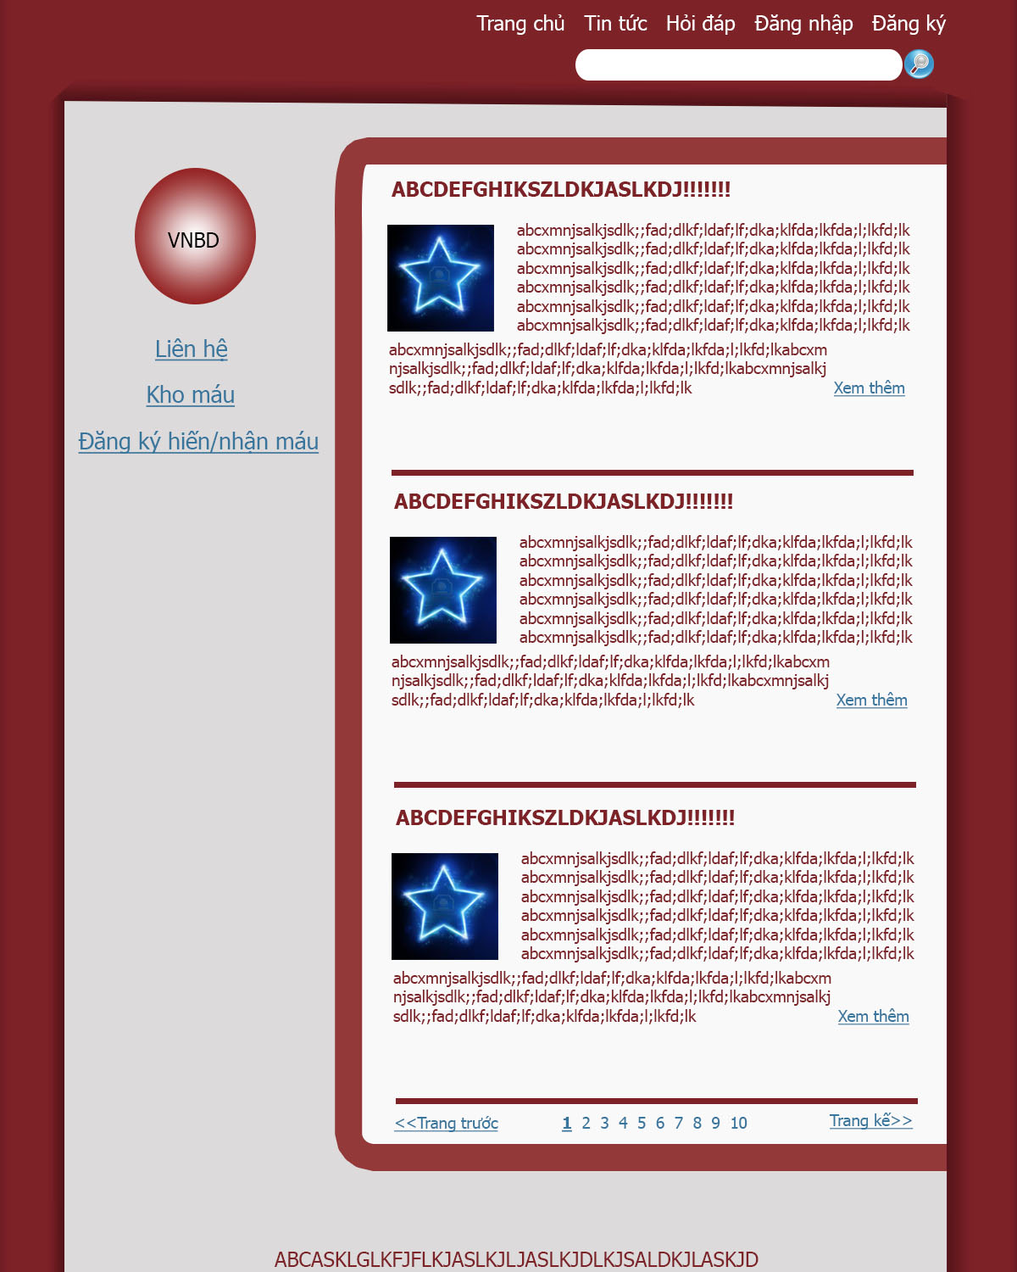

|  |  |  |  |  |  |
| --- | --- | --- | --- | --- | --- |
| No | Component Name | Required | Format | Reference | Note |
| 1 | Homepage | Click | Button | Homepage screen | Refresh homepage |
| 2 | News | Click | Button | News screen | Link to news screen |
| 3 | Q&A | Click | Button | Q&A screen | Link to Q&A screen |
| 4 | Contact | Click | Button | Contact screen | Link to Contact screen |
| 5 | Blood’s storehouse | Click | Button | Blood’s storehouse screen | Link to Blood’s storehouse screen |
| 6 | Register | Click | Button | Register screen | Link to register screen |
| 7 | Register to donate/receive blood | Click | Button | Register to donate/receive blood screen | Link to Register to donate/receive blood screen |
| 8 | Login | Click | Button | Login screen | Link to login screen |
| 9 | VNBD label |  | Text |  | Display VNBD label |
| 10 | Search textbox | Text | Text |  | Input search keyword |
| 11 | Search button | Click | Button |  | Search information |
| 12 | Slogan label |  | Text |  | Display Slogan label |
| 13 | Post’s name |  | Text |  | Display post’s name |
| 14 | Post’s pictures |  | Image |  | Display post’s picture |
| 15 | A part of post comment |  | Text |  | Display a part of post’s content |
| 16 | Read more button | Click | Button | View full post screen | Link to post’s full screen |
| 17 | Previous page button | Click | Button |  | Display previous page of posts |
| 18 | Page index | Click | Button |  | Click to select the index of post’s page |
| 19 | Next page button | Click | Button |  | Display next page of posts |

## Q&A

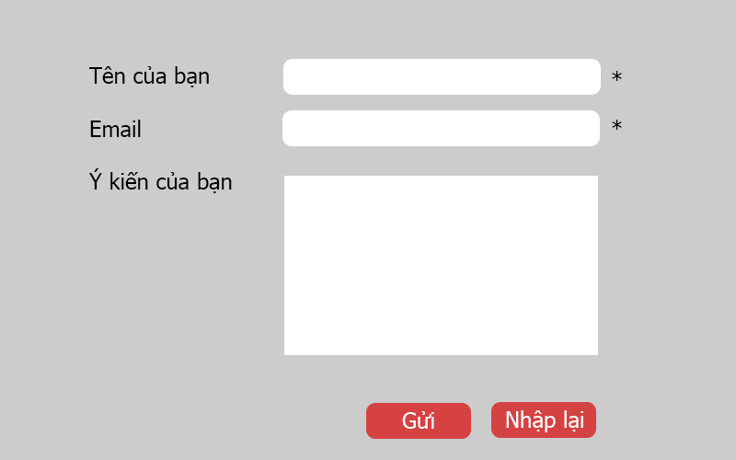

|  |  |  |  |  |  |
| --- | --- | --- | --- | --- | --- |
| No | Component Name | Required | Format | Reference | Note |
| 1 | Name | Text | Text |  | Input name of user |
| 2 | Email | Text | Text |  | Input email of user |
| 3 | Comment | Text | Text |  | Input description of QA comment |
| 4 | Cancel | Click | Button | Homepage | Delete all information in description textbox |
| 5 | Send | Click | Button |  | Send information of QA comment |
| 6 | Name Label |  | Text |  | Display : user’s name |
| 7 | Email label |  | Text |  | Display : user’s email |
| 8 | Comment label |  | Text |  | Display : comment |
| 9 | “*” Label |  | Text |  | Display : “*” |

## Contact screen

`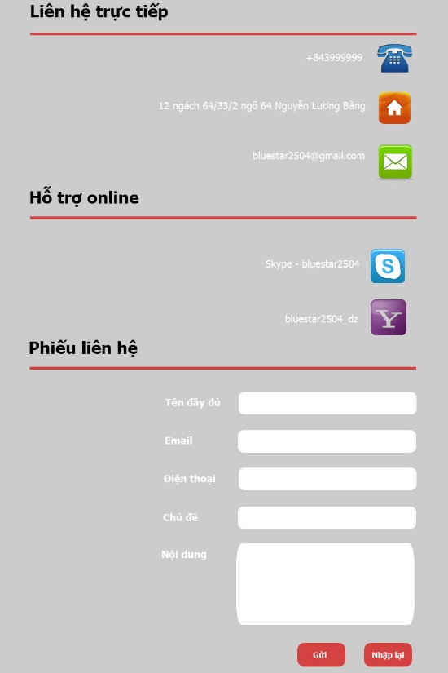

|  |  |  |  |  |  |
| --- | --- | --- | --- | --- | --- |
| No | Component Name | Required | Format | Reference | Note |
| 1 | Name | Text | Text |  | Input name of user |
| 2 | Email | Text | Text |  | Input email of user |
| 3 | Mobile number | Text | Text |  | Input mobile number of user |
| 4 | Topic | Text | text |  | Input topic of Contact ticket |
| 5 | Send | Click | Button |  | Send information of QA comment |
| 6 | Re-input | Click | Button | Homepage | Delete all information in description textbox |
| 7 | Contact directly |  | Text |  | Display : Contact directly |
| 8 | Telephone picture |  | Image |  | Display Telephone picture |
| 9 | Telephone label |  | Text |  | Display telephone number of VNBD group |
| 10 | Address picture |  | Image |  | Display Address picture |
| 11 | Address label |  | Text |  | Display address of VNBD group |
| 12 | Email picture |  | Image |  | Display Email picture |
| 13 | Email label |  | Text |  | Display email of VNBD group |
| 14 | Online support label |  | Text |  | Display : Online support label |
| 15 | Skype image |  | Image |  | Display Skype image |
| 16 | Skype label |  | Text |  | Display Skype account of VNBD group |
| 17 | Yahoo image |  | Image |  | Display Yahoo image |
| 18 | Yahoo label |  | Text |  | Display yahoo account of VNBD group |
| 19 | Support ticket label |  | Text |  | Display : Support ticket label |
| 20 | Name label |  | Text |  | Display :name |
| 21 | Email label |  | Text |  | Display : email |
| 22 | Mobile phone |  | Text |  | Display : mobile phone |
| 23 | Topic of support ticket |  | Text |  | Display : topic |
| 24 | Support ticket information |  | Text |  | Display : information |

## Blood’s storehouse

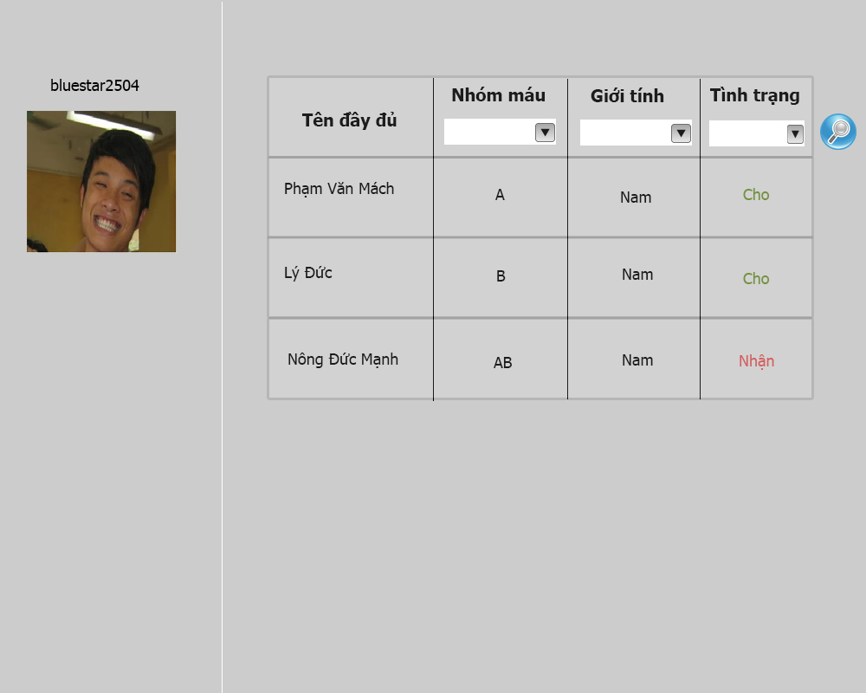

|  |  |  |  |  |  |
| --- | --- | --- | --- | --- | --- |
| No | Component Name | Required | Format | Reference | Note |
| 1 | User’s name label |  | Text |  | Display user’s name |
| 2 | User’s avatar |  | Image |  | Display User’s avatar |
| 3 | Name label |  | Text |  | Display: name of user |
| 4 | User’s name |  | Text |  | Display name of users |
| 5 | Blood group label |  | Text |  | Display : blood group |
| 6 | Blood Group DDL | Select | Drop  Down  list |  | Select Blood group to search |
| 7 | User’s blood group |  | Text |  | Display selected user’s blood group |
| 8 | Gender | Click | Drop  Down  List |  | Select gender to search |
| 9 | Gender label |  | Text |  | Display : gender |
| 10 | User’s gender |  | Text |  | Display selected user’s gender |
| 11 | Status label |  | Text |  | Display : status |
| 12 | Status | Select | Drop  Down  List |  | Select status to search |
| 13 | User’s status |  | Image |  | Display selected user’s status |
| 14 | Search button | Click | Button |  | Search information by choose Blood group , gender and status |

## Register

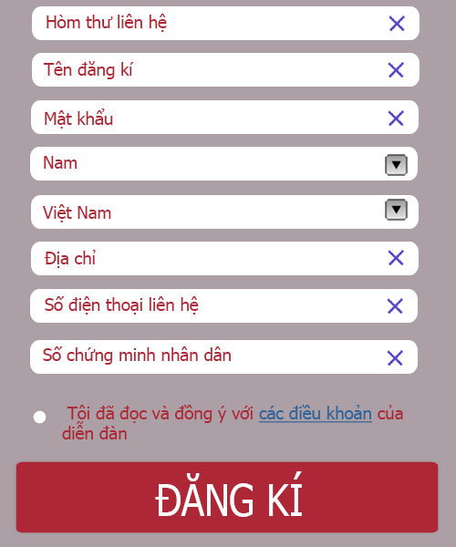

|  |  |  |  |  |  |
| --- | --- | --- | --- | --- | --- |
| No | Component Name | Required | Format | Reference | Note |
| 1 | Email | Text | Text |  | Input email of user |
| 2 | User name | Text | Text |  | Input user name |
| 3 | Password | Text | Text |  | Input password |
| 4 | Gender | select | Drop  Down  List |  | Input gender by select dropdown list |
| 5 | Nation | select | Drop  Down  List |  | Input nation by select dropdown list |
| 6 | Address | Text | Text |  | Input address of user |
| 7 | Mobile number | Number | Text |  | Input mobile number of user |
| 8 | Identification number | Number | Text |  | Input identification number of user |
| 9 | TOS check | Click | Radio button |  | Tick to agree to TOS |
| 10 | TOS | Click | Hyper link | TOS screen | Click to go to TOS screen |
| 11 | Register Button | Click | Button |  | Click to register user |

## Choose type of register (donate or receive)

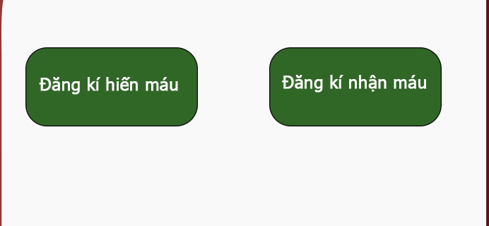

|  |  |  |  |  |  |
| --- | --- | --- | --- | --- | --- |
| No | Component Name | Required | Format | Reference | Note |
| 1 | Donate button | Click | Button | Register to donate blood screen | Click to go to Register to donate blood screen |
| 2 | Receive button | Click | Button | Register to receive blood screen | Click to go to Register to receive blood screen |

## Register to donate blood

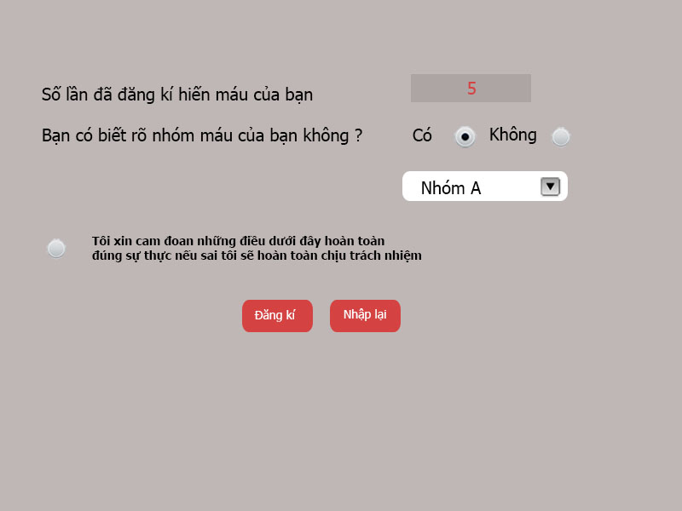

|  |  |  |  |  |  |
| --- | --- | --- | --- | --- | --- |
| No | Component Name | Required | Format | Reference | Note |
| 1 | Number of donation label |  | Text |  | Display : Number of donation |
| 2 | Number of donation |  | Text |  | Display : Number of donation |
| 3 | Do u know label |  | Text |  | Display : Do you know certainly about your blood group |
| 4 | Yes label |  | Text |  | Display: Yes |
| 5 | No label |  | Text |  | Display : No |
| 6 | Yes/no radio button | Click | Radio button |  | Click to choose yes or no |
| 7 | Blood group DDL | Select | Drop down list |  | Choose blood group |
| 8 | Assure radio button | Click | Radio button |  | Click to assure that … |
| 9 | Assure label |  | Text |  | Display condition of register for blood donation |
| 10 | Register button | Click | Button |  | Click to register for blood donation |
| 11 | Cancel | Click | Button |  | Refresh page |

## Register to receive blood

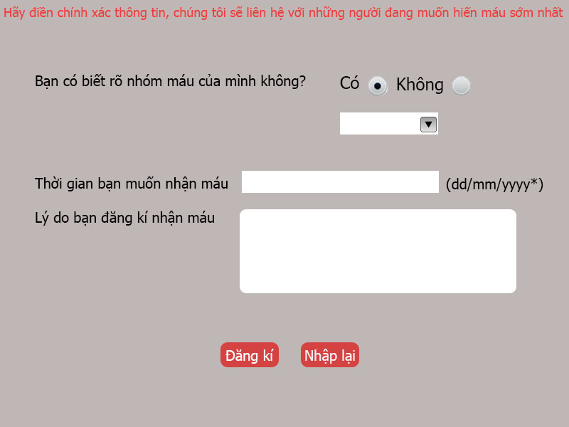

|  |  |  |  |  |  |
| --- | --- | --- | --- | --- | --- |
| No | Component Name | Required | Format | Reference | Note |
| 1 | Do u know label |  | Text |  | Display : Do you know certainly about your blood group |
| 2 | Yes label |  | Text |  | Display: Yes |
| 3 | No label |  | Text |  | Display : No |
| 4 | Yes/no radio button | Click | Radio button |  | Click to choose yes or no |
| 5 | Blood group DDL | Select | Drop down list |  | Choose blood group |
| 6 | Notice label |  | Text |  | Display notice from VNBD |
| 7 | Register button | Click | Button |  | Click to register for blood donation |
| 8 | Cancel | Click | Button |  | Refresh page |
| 9 | Time you want to receive blood label |  | Text |  | Display: Time you want to receive blood |
| 10 | Time you want to receive blood |  | Text |  | Input time you want to receive blood ( dd/mm/yyyy) |
| 11 | Reason why you want to register for receive blood label |  | Text |  | Display : Reason why you want to register for receive blood |
| 12 | Reason why you want to register for receive blood |  | Text |  | Input your reason |

## Login screen

## 

|  |  |  |  |  |  |
| --- | --- | --- | --- | --- | --- |
| No | Component Name | Required | Format | Reference | Note |
| 1 | Login name |  | Text |  | Input Login name |
| 2 | Password |  | Text |  | Input password login |
| 3 | Remember me | Click | Checkbox |  | Check to remember username and password for this user |
| 4 | Forgot password | Click | Hyper link | Forgot password screen | Click to go to Forgot password screen |
| 5 | Login button | Click | Button |  | Click to login |
| 6 | Register | Click | Hyper link | Register user screen | Click to go to register user screen |
| 7 | Remember me label |  | Text |  | Display : remember me |

## Forgot password screen

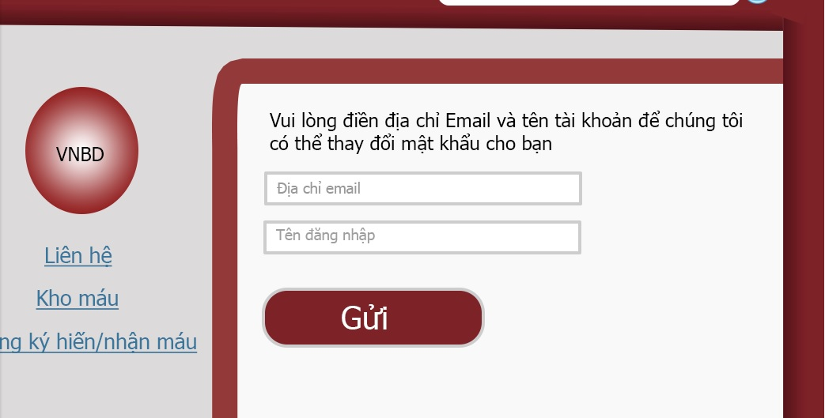

|  |  |  |  |  |  |
| --- | --- | --- | --- | --- | --- |
| No | Component Name | Required | Format | Reference | Note |
| 1 | Notice label |  | Text |  | Display notice from VNBD group |
| 2 | Email textbox | Text | Text |  | Input user’s email |
| 3 | Username textbox | Text | Text |  | Input username |
| 4 | Send button | Click | Button |  | Click to send an email to VBND group to reset password |

## Term of service Screen

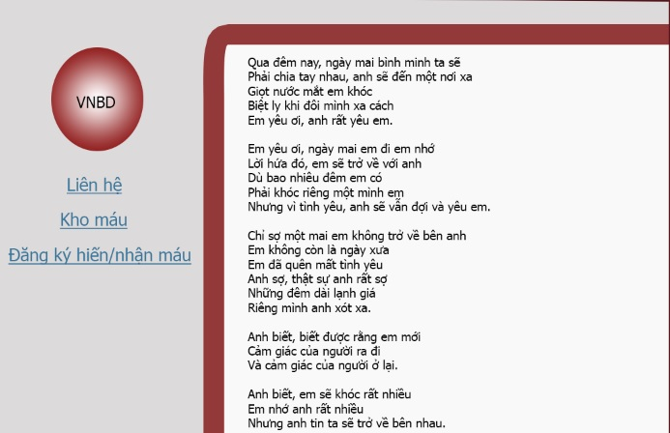

|  |  |  |  |  |  |
| --- | --- | --- | --- | --- | --- |
| No | Component Name | Required | Format | Reference | Note |
| 1 | TOS content |  | Text |  | Display full term of services |

## Edit profile screen

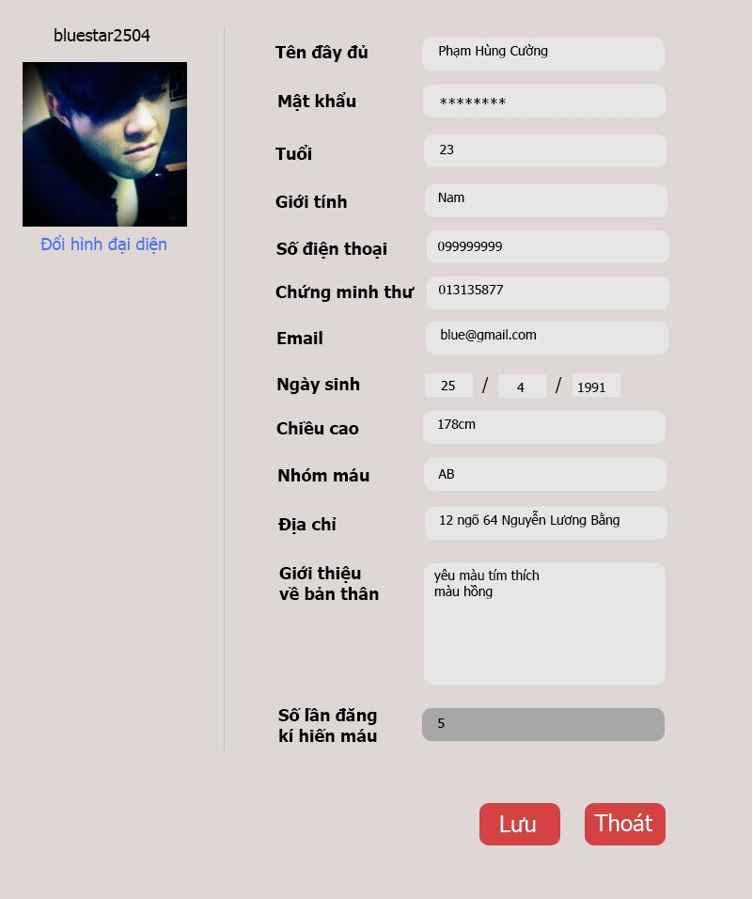

|  |  |  |  |  |  |
| --- | --- | --- | --- | --- | --- |
| No | Component Name | Required | Format | Reference | Note |
| 1 | User name label |  | Text |  | Display User name |
| 2 | Avatar picture |  | Image |  | Display user’s avatar |
| 3 | Change avatar button |  | Button |  | Click to upload a new avatar picture |
| 4 | Full name label |  | Text |  | Display: Full name |
| 5 | Full name textbox | Text | Text |  | Display old full name , click to edit |
| 6 | Password | Text | Text |  | Click to input new password |
| 7 | Password label |  | Text |  | Display : Password |
| 8 | Age label |  | Text |  | Display : Age |
| 9 | Age textbox | Text | Text |  | Display age , click to edit |
| 10 | Gender label |  | Text |  | Display: Gender |
| 11 | Gender textbox | Text | Text |  | Display gender , click to edit |
| 12 | Mobile number label |  | Text |  | Display : Mobile number |
| 13 | Mobile number textbox | Text | Text |  | Display mobile number , click to edit |
| 14 | ID number label |  | Text |  | Display : ID number |
| 15 | ID number textbox | Text | Text |  | Display ID number , click to edit |
| 16 | Email label |  | Text |  | Display : Email |
| 17 | Email textbox | Text | Text |  | Display email , click to edit |
| 18 | DOB label |  | Text |  | Display : Date of birth |
| 19 | Day textbox | Text | Text |  | Display day of birth , click to edit |
| 20 | Month textbox | Text | Text |  | Display month of birth , click to edit |
| 21 | Year textbox | Text | Text |  | Display year of birth , click to edit |
| 22 | “/” label |  | Text |  | Display “/” to divide month , day, year |
| 23 | Height |  | Text |  | Display : Height |
| 24 | Height textbox | Text | Text |  | Display height , click to edit |
| 25 | Blood group label |  | Text |  | Display: blood group |
| 26 | Blood group textbox |  | Text |  | Display user’s blood group |
| 27 | Address label |  | Text |  | Display: Address |
| 28 | Address textbox | Text | Text |  | Display address , click to edit |
| 29 | About me label |  | Text |  | Display : About me |
| 30 | About me textbox | Text | Text |  | Display about me information , click to edit |
| 31 | Number of donation label |  | Text |  | Display : Number of donation |
| 32 | Number of donation textbox | Text | Text |  | Display Number of donation |
| 33 | Save button | Click | Button |  | Click to save edit |
| 34 | Exit | Click | Button | Homepage screen | Click to go back to homepage |

## Gallery

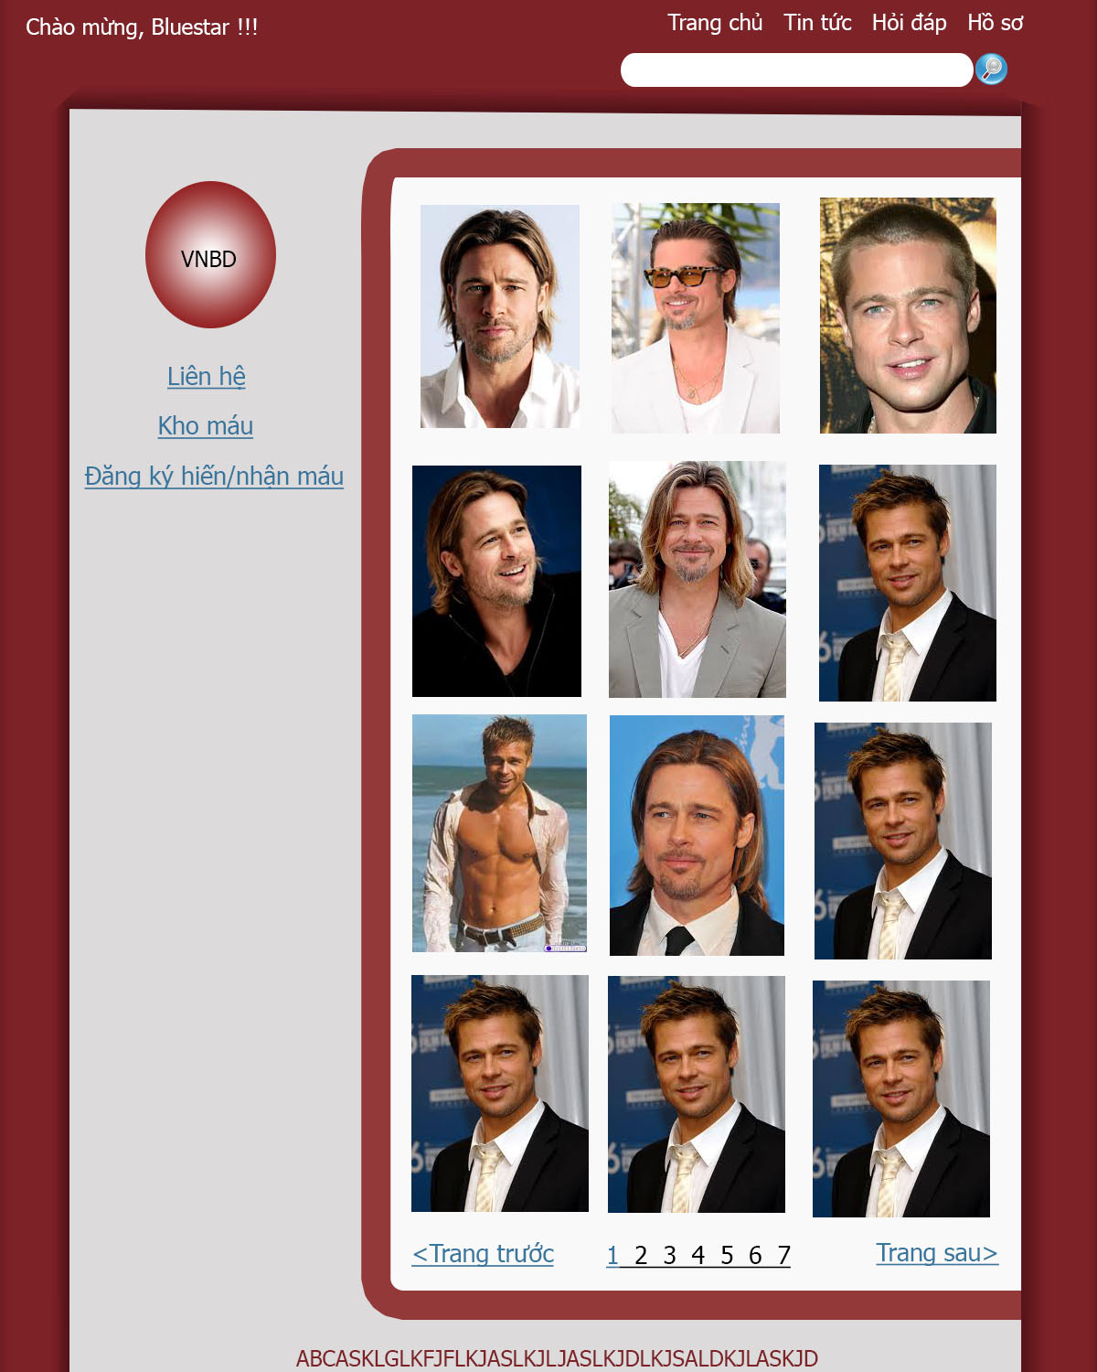

|  |  |  |  |  |  |
| --- | --- | --- | --- | --- | --- |
| No | Component Name | Required | Format | Reference | Note |
| 1 | Picture 1 |  | Image button | Full picture screen | Display picture 1 |
| 2 | Picture 1 |  | Image button | Full picture screen | Display picture 2 |
| 3 | Picture 3 |  | Image button | Full picture screen | Display picture 3 |
| 4 | Picture 4 |  | Image button | Full picture screen | Display picture 4 |
| 5 | Picture 5 |  | Image button | Full picture screen | Display picture 5 |
| 6 | Picture 6 |  | Image button | Full picture screen | Display picture 6 |
| 7 | Picture 7 |  | Image button | Full picture screen | Display picture 7 |
| 8 | Picture 8 |  | Image button | Full picture screen | Display picture 8 |
| 9 | Picture 9 |  | Image button | Full picture screen | Display picture 9 |
| 10 | Previous page button | Click | Button |  | Display previous page of picture |
| 11 | Page index | Click | Button |  | Click to select the index of picture’s page |
| 12 | Next page button | Click | Button |  | Display next page of picture |

## View full picture

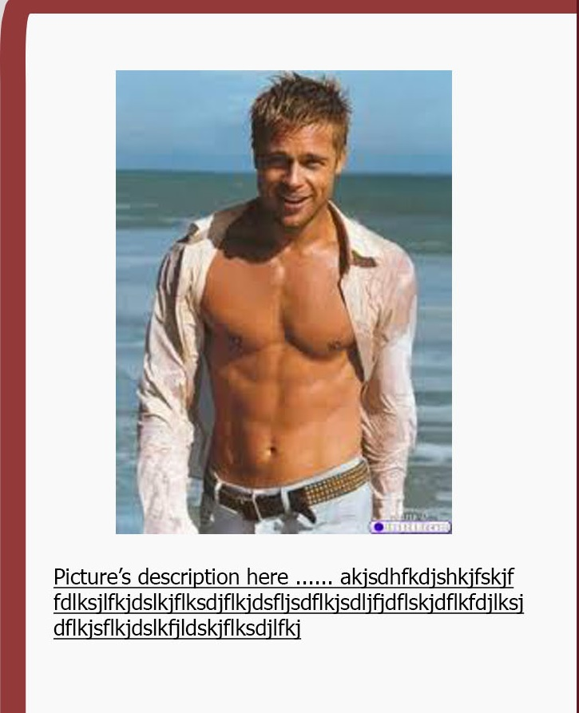

|  |  |  |  |  |  |
| --- | --- | --- | --- | --- | --- |
| No | Component Name | Required | Format | Reference | Note |
| 1 | Picture |  | Image |  | Display full size picture |
| 2 | Picture information |  | Text |  | Display picture’s information |

## Videos

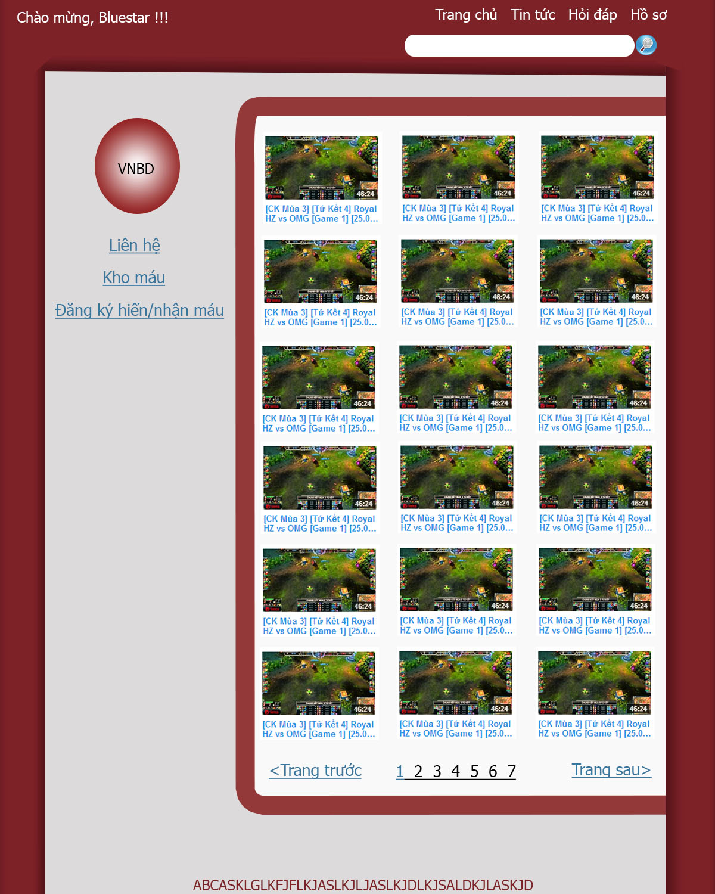

|  |  |  |  |  |  |
| --- | --- | --- | --- | --- | --- |
| No | Component Name | Required | Format | Reference | Note |
| 1 | Video | Click | Video | Youtube.com | Click to view full video in youtube.com |
| 2 | Video’s description |  | Text | Youtube.com | Click to view full video in youtube.com |
| 3 | Previous page button | Click | Button |  | Display previous page of video |
| 4 | Page index | Click | Button |  | Click to select the index of video’s page |
| 5 | Next page button | Click | Button |  | Display next page of video |

## History of blood donate/receive registration (for admin)

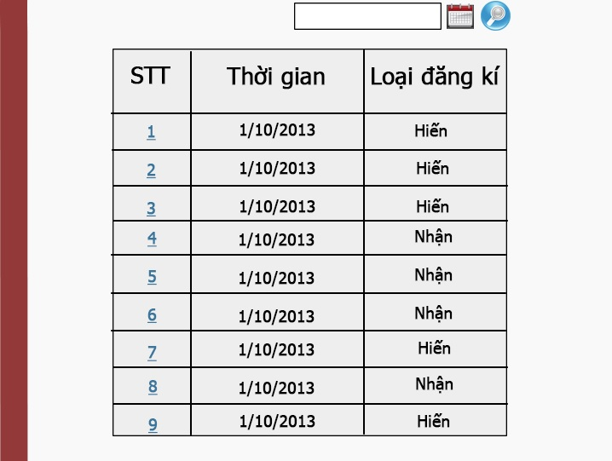

|  |  |  |  |  |  |
| --- | --- | --- | --- | --- | --- |
| No | Component Name | Required | Format | Reference | Note |
| 1 | Search textbox | Text | Text (dd/mm/yyyy) |  | Input search information |
| 2 | Calendar | Click | Image button |  | Click to choose date for search textbox |
| 3 | STT label |  | Text |  | Display “STT” |
| 4 | Time label |  | Text |  | Display “Time” |
| 5 | Type of registration label |  | Text |  | Display “Type of registration” |
| 6 | STT number | Click | Hyper link | View full information’s screen | Click to go to full information’s screen |
| 7 | Time |  | Text |  | Display time of registration |
| 8 | Type of registration |  | Text |  | Display type of registration |
| 10 | Previous page button | Click | Button |  | Display previous page |
| 11 | Page index | Click | Button |  | Click to select the index |
| 12 | Next page button | Click | Button |  | Display next page |

## 

## View full History of blood donate/receive registration (for admin)

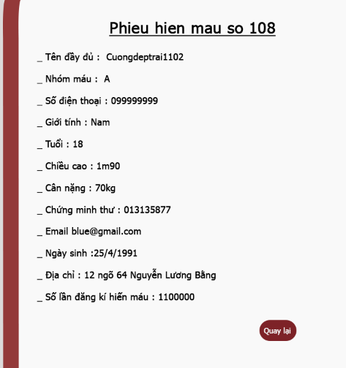

|  |  |  |  |  |  |
| --- | --- | --- | --- | --- | --- |
| No | Component Name | Required | Format | Reference | Note |
| 1 | Number of registration ticket |  | Text |  | Display Number of registration ticket |
| 2 | Full name |  | Text |  | Display full name of user |
| 3 | Blood group |  | Text |  | Display blood group of user |
| 4 | Contact number |  | Text |  | Display contact number |
| 5 | Gender |  | Text |  | Display gender |
| 6 | Age |  | Text |  | Display age |
| 7 | Height |  | Text |  | Display height |
| 8 | Weight |  | Text |  | Display weight |
| 9 | ID number |  | Text |  | Display ID number |
| 10 | Email |  | Text |  | Display email |
| 11 | DOB |  | Text |  | Display DOB |
| 12 | Address |  | Text |  | Display address |
| 13 | Number of register for donate/receive blood |  | Text |  | Display Number of register for donate/receive blood |
| 14 | Back button | Click | Button | View all ticket screen | Click to go back to the view all ticket screen |

# Other considerations